WEBSITE CONTENT DRAFT — DETAILED REPORT
Paperforce India LLP
Corporate Website — Page-by-Page Content & Section Breakdown
This version expands the initial draft into a full section-by-section specification for every page: what each section is for, what content and assets it needs, the drafted copy itself, and every CTA on the page — ready for client review and handoff to design/development.

Project Reference
Domain | paperforceindia.com (already purchased)
Hosting Region | Singapore or US — see recommendation below
Site Motto / Positioning | To be seen as a manufacturer of stationery items (not just a trader/exporter)
Target Countries | USA · Middle East (Saudi Arabia, UAE/Dubai, Oman, Israel, Bahrain) · West Africa · UK · Latin America
Target Consumers | B2B — importers & traders, stationery importers, chain stores, stationery brands, educational institutes; business buyers and sole traders (25+)
Site Navigation | Home · About Us and Infrastructure · Products · Contact Us · Blog · Reach/Markets
Social Channels | Facebook, Instagram, LinkedIn, Pinterest
Contact Channel Note | Business WhatsApp is a separate number from the personal WhatsApp — to be listed distinctly on the Contact page

Content note: Hosting — with buyers spread across the US, UK, Middle East, West Africa and Latin America, Singapore-based hosting paired with a CDN generally gives balanced latency across the Middle East, Africa and Asia-adjacent traffic, while a US server favours North & Latin American visitors. Either origin works well if placed behind a CDN (e.g. Cloudflare) so all regions load near-locally.

Contents
- 1. Home
- 2. About Us and Infrastructure
- 3. Products
- 4. Contact Us
- 5. Blog
- 6. Reach / Markets
- 7. Open Items — Information Needed From Client

Site Structure Overview
Six pages hang off a single Home hub. Every secondary page also carries its own path back to Contact Us, so a buyer is never more than one click from starting an enquiry.
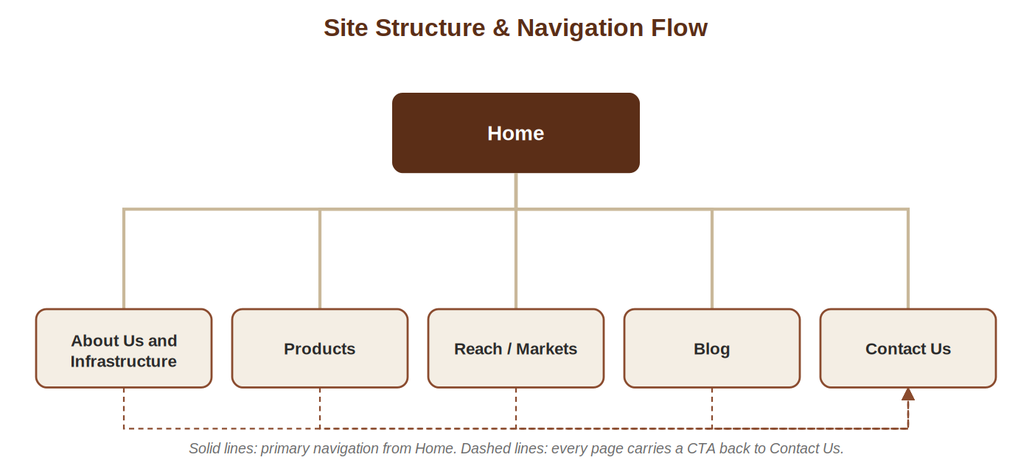

1. Home

Page Goal
Establish Paperforce India as a genuine manufacturer (not a trader), build immediate credibility with B2B buyers, and route visitors toward Products, Reach/Markets or a direct enquiry within the first screen or two.

SEO Snapshot
URL | paperforceindia.com/
Title Tag | Paperforce India | Notebook & Paper Stationery Manufacturer & Exporter
Meta Description | Paperforce India LLP manufactures and exports notebooks and paper stationery from Palghar, Maharashtra to importers worldwide. AQL-quality assured — request a quote.
Target Keywords
notebook manufacturer India • paper stationery exporter • bulk notebook supplier • stationery manufacturer Mumbai • B2B stationery exporter

Section Breakdown
# | Section | Purpose | Key Content & Assets
1 | Header / Navigation | Persistent access to every page and a fast contact route | Logo, nav links (Home, About Us and Infrastructure, Products, Reach/Markets, Blog, Contact Us), sticky Business WhatsApp click-to-chat icon
2 | Hero | First-screen impression: manufacturer positioning + immediate action | Headline, sub-headline, factory/product hero image, two buttons (“Explore Our Products”, “Partner With Us”)
3 | Trust Strip | Quantify credibility before buyer scrolls further | 4 stat tiles: 10+ Years Experience · Legacy Since 1988 · AQL-Inspected Quality · Exports via JNPT
4 | Who We Are | Bridge to the full story without duplicating the About page | 2–3 sentence summary + “Read Our Story” link to About Us and Infrastructure
5 | Why Buyers Choose Us | Turn credentials into buyer-relevant reasons to enquire | 4 value-prop cards with icons (see copy below)
6 | Product Range Teaser | Show manufacturing breadth, drive to Products page | Icon/thumbnail grid of the 6 notebook types + “View All Products” button
7 | Global Reach Teaser | Reassure export-capability at a glance | Small world-map graphic, region names, “See Our Markets” button
8 | Who We Serve | Help each buyer segment self-identify | 4 tags: Importers & Traders, Chain Stores, Stationery Brands, Educational Institutes
9 | Insights Teaser | Signal expertise, support SEO, encourage return visits | 3 article cards pulled from Blog (placeholder titles until launch posts are live)
10 | Call-to-Action Banner | Capture ready-to-enquire visitors before the footer | Short prompt + “Request a Quote” button
11 | Footer | Secondary navigation + always-visible contact | Nav links, office/facility snapshot, social icons, Business WhatsApp number, copyright line

Section Copy
1. Hero
Headline: “Manufacturing Quality Paper Stationery for the World.”
Sub-headline: A decade of manufacturing and export experience. Three decades of paper trade heritage. One dependable partner for your notebook and stationery sourcing.
Buttons: “Explore Our Products” · “Partner With Us”
2. Trust Strip
- 10+ Years — hands-on manufacturing & export experience
- Since 1988 — three decades of family heritage in the paper logistics trade
- AQL-Inspected — every shipment checked before dispatch
- JNPT Export — shipped worldwide via Nhava Sheva, India's leading container port
3. Who We Are
At Paperforce India LLP, we manufacture and export paper stationery to distributors, wholesalers and importers across the globe — combining hands-on production experience with the scale that high-volume export orders demand.
4. Why Buyers Choose Us
- Decade of Manufacturing & Export Experience — hands-on production know-how built over 10+ years serving international markets.
- Family Legacy Since 1988 — three decades of accumulated trust and relationships in the paper logistics trade.
- AQL-Inspected Quality — every shipment checked against defined Acceptable Quality Limit standards before it leaves our facility.
- Global Export Network — shipping worldwide through Nhava Sheva (JNPT), India's leading container gateway.
5. Product Range Teaser
We manufacture a wide range of notebooks — exercise books, spiral bound, double wire bound, hard cover Gally bound, centre stitched and glue bound — alongside a growing paper packaging vertical.
6. Global Reach Teaser
From West Africa to the Middle East, the UK to the Americas — see where Paperforce India currently trades.
7. Who We Serve
Importers & Traders · Chain Stores · Stationery Brands · Educational Institutes
8. Call-to-Action Banner
Ready to source with a manufacturer you can rely on? Request a quote and our export team will respond with pricing, MOQs and lead times.

CTAs on This Page
- Hero → “Explore Our Products” (Products) and “Partner With Us” (Contact Us)
- Who We Are → “Read Our Story” (About Us and Infrastructure)
- Product Teaser → “View All Products” (Products)
- Reach Teaser → “See Our Markets” (Reach/Markets)
- CTA Banner → “Request a Quote” (Contact Us)

Assets & Info Needed
- Hero image: factory floor, notebook production line, or styled product flat-lay
- Icons for the 4 trust-strip stats and 4 value-prop cards
- Thumbnails for the 6 notebook types (or a single grouped product shot)
- 3 launch blog post titles + thumbnails, once Blog content is approved

2. About Us and Infrastructure

Page Goal
Convert manufacturing credibility into buyer trust — prove Paperforce India is an established, well-resourced factory (not a trading middleman) with the heritage and infrastructure to fulfil recurring, high-volume export orders.

SEO Snapshot
URL | paperforceindia.com/about-us
Title Tag | About Us | Notebook Manufacturer in Palghar, Maharashtra – Paperforce India
Meta Description | Paperforce India LLP: family heritage in the paper trade since 1988, manufacturing notebooks and stationery from our Palghar, Maharashtra facility for global export.
Target Keywords
notebook manufacturing Palghar • paper stationery manufacturer Maharashtra • Paperforce India LLP • notebook factory India • Mumbai stationery exporter

Section Breakdown
# | Section | Purpose | Key Content & Assets
1 | Page Banner | Orient the visitor, reinforce brand | Title “About Us and Infrastructure”, breadcrumb (Home / About Us), supporting facility image
2 | Our Story | Establish heritage and long-term credibility | Narrative copy: Mumbai HQ, decade of manufacturing/export experience, family legacy since 1988
3 | Heritage Timeline | Make the 3-decade legacy tangible and scannable | Visual timeline: 1988 (paper logistics trade begins) → manufacturing decade begins → present day — exact milestone years pending from client
4 | Our Manufacturing Facility | Prove production capability behind the brand | Palghar, Maharashtra location; skilled workforce, supply chain, production capacity narrative
5 | Infrastructure Highlights | Give buyers concrete, scannable capability signals | 4 icon tiles: Skilled Workforce · Established Supply Chain · Export-Ready Production Capacity · Facility Location (Palghar cluster) — figures pending from client
6 | Quality & Compliance | Address the #1 B2B sourcing concern: consistency | AQL inspection explanation; certification badges (ISO/FSC/BIS) once confirmed
7 | Our Mission | State the brand's positioning in the buyer's own terms | “To be recognised globally as a manufacturer of stationery items” reframed as a client promise
8 | Why Partner With Us | Summarise the case for choosing Paperforce India | 6-point bullet list (direct manufacturer, workforce, supply chain, capacity, AQL, heritage)
9 | CTA Section | Move a persuaded visitor to the next logical page | “Learn About Our Products” button + secondary “Get in Touch” link

Section Copy
1. Our Story
Headquartered in Mumbai, Paperforce India LLP brings over a decade of hands-on experience manufacturing and exporting paper stationery to international markets. Our connection to the paper trade runs deeper still — three decades, in fact — through a family history connected to the paper logistics trade since 1988. That heritage shapes the way we manufacture, ship and build relationships today: built on trust, timeliness and consistency.
2. Heritage Timeline
1988 — Family roots established in the paper logistics trade. → Manufacturing operations begin, building over a decade of hands-on production and export experience. → Today — Paperforce India LLP exports across five global regions from our Palghar facility.
Exact founding/incorporation year and any intermediate milestones should be confirmed with the client so the timeline reads as fact rather than approximation.
3. Our Manufacturing Facility
Our manufacturing facility is based in Palghar, Maharashtra — a recognised hub for notebook manufacturing in India. This location gives us direct access to a skilled workforce, established raw-material supply chains, and the production capacity required to fulfil high-volume export orders reliably and on schedule.
4. Infrastructure Highlights
- Skilled Workforce — experienced production staff based in an established notebook-manufacturing cluster.
- Established Supply Chain — reliable raw-material sourcing that supports consistent lead times.
- Export-Ready Production Capacity — built to handle recurring, high-volume export orders.
- Strategic Location — Palghar's manufacturing ecosystem plus proximity to Nhava Sheva (JNPT) for efficient export logistics.
5. Quality & Compliance
Every product is inspected against defined AQL (Acceptable Quality Limit) standards before it leaves our facility, ensuring consistent quality across every shipment — whether it's a trial order or a container-load consignment.
6. Our Mission
Our goal is simple: to be recognised globally not just as an exporter, but as a genuine manufacturer of stationery items — one that delivers consistent quality, reliable timelines, and long-term partnership value to every importer, distributor and wholesaler we work with.
7. Why Partner With Us
- Direct manufacturer — no middlemen between factory and your order
- Skilled, experienced production workforce based in a notebook-manufacturing cluster
- Established supply chain for raw materials and consistent lead times
- Production capacity built for high-volume, recurring export orders
- AQL-based quality inspection on every shipment
- Three decades of family heritage in the paper logistics trade

CTAs on This Page
- Page-end → “Learn About Our Products” (Products)
- Secondary link → “Get in Touch” (Contact Us)

Assets & Info Needed
- Facility/factory photography (exterior, production floor, workforce)
- Confirmed founding/incorporation year and any milestone years for the timeline
- Workforce size, production capacity figures, and machinery highlights
- Certifications, if any (ISO, FSC, BIS, etc.), with certificate images

3. Products

Page Goal
Give sourcing buyers everything they need to shortlist Paperforce India: a clear product range, visible quality process, and an easy path to request a catalogue or quote.

SEO Snapshot
URL | paperforceindia.com/products
Title Tag | Notebook Products | Spiral, Wire, Gally & Glue Bound Notebooks – Paperforce India
Meta Description | Explore Paperforce India's notebook range — exercise books, spiral and double wire bound, hard cover Gally bound, centre stitched and glue bound notebooks, plus paper packaging.
Target Keywords
spiral bound notebook manufacturer • wire bound notebook exporter • exercise book manufacturer India • Gally bound notebook • glue bound notebook supplier • paper packaging manufacturer India

Section Breakdown
# | Section | Purpose | Key Content & Assets
1 | Page Banner | Orient the visitor, set expectations for the page | Title “Products”, breadcrumb, supporting product image
2 | Introduction | Frame the range as export-ready and quality-inspected | Short intro paragraph positioning the range for B2B buyers
3 | Notebook Range | Primary product showcase — the core of this page | 6-item grid: Exercise Books, Spiral Bound, Double Wire Bound, Hard Cover Gally Bound, Centre Stitched, Glue Bound — each with description + product photo
4 | Paper Packaging | Introduce the growing second product vertical | Short intro; formats/specs pending from client
5 | Customisation & Private Label | Answer a common B2B question before it's asked | Confirm with client whether OEM/private-label branding, custom sizing, or paper-GSM options are offered
6 | Quality Assurance Process | Make the AQL claim tangible and process-based | 4-step visual: Raw Material Check → In-Process Check → Pre-Shipment AQL Inspection → Dispatch
7 | Catalogue / Samples CTA | Convert interest into a lead capture moment | “Download Product Catalogue” + “Request Samples” buttons
8 | CTA Section | Final push to enquiry for undecided visitors | “Get a Quote” button routing to Contact Us

Section Copy
1. Introduction
We manufacture a comprehensive range of notebooks designed to meet the sourcing needs of distributors, wholesalers, chain stores, stationery brands and educational institutes worldwide. Every product is produced in-house at our Palghar facility and inspected against defined AQL standards before dispatch.
2. Notebook Range
- Exercise Books — everyday notebooks for school and office use, produced at export volume.
- Spiral Bound Notebooks — durable wire-coil binding for a smooth, lay-flat writing experience.
- Double Wire Bound Notebooks — reinforced double-loop wire construction for frequent, heavy use.
- Hard Cover Gally Bound Notebooks — premium bound notebooks with a rigid protective cover.
- Centre Stitched Notebooks — classic saddle-stitched exercise books for high-volume, cost-conscious orders.
- Glue Bound Notebooks — adhesive-bound notebooks offering a reliable, economical option.
3. Paper Packaging
Alongside our notebook range, we are growing a dedicated paper packaging vertical, extending our manufacturing capability into paper-based packaging solutions — built to the same AQL-inspected quality standard as our notebooks.
4. Customisation & Private Label
[Pending client confirmation] Buyers sourcing at volume often ask about private-label branding, custom cover printing, or specific paper GSM/page-count configurations. If Paperforce India offers any of these, this section should state it explicitly — it's a strong differentiator for chain-store and stationery-brand buyers.
5. Quality Assurance Process
1. Raw Material Check → 2. In-Process Quality Check → 3. Pre-Shipment AQL Inspection → 4. Dispatch. Every order — from first sample to full container load — follows this process, so what you approve in a sample is what arrives at your port.

CTAs on This Page
- Catalogue block → “Download Product Catalogue” / “Request Samples”
- Page-end → “Get a Quote” (Contact Us)

Assets & Info Needed
- Product photography for all 6 notebook types (and packaging, once specified)
- Paper packaging formats and specifications
- Confirmation on private-label / customisation capability
- Downloadable PDF catalogue (can be produced once product photos and specs are ready)

4. Contact Us

Page Goal
Make it effortless for a qualified B2B buyer to start a conversation — clear contact channels, a low-friction enquiry form, and enough reassurance (FAQ) to reduce back-and-forth before the first reply.

SEO Snapshot
URL | paperforceindia.com/contact-us
Title Tag | Contact Us | Paperforce India – Notebook & Stationery Export Enquiries
Meta Description | Get in touch with Paperforce India LLP for bulk notebook and paper stationery export enquiries. Manufacturing facility in Palghar, Maharashtra, exporting worldwide via JNPT.
Target Keywords
contact notebook exporter India • notebook manufacturer enquiry • bulk stationery order India • Paperforce India contact

Section Breakdown
# | Section | Purpose | Key Content & Assets
1 | Page Banner | Orient the visitor, set a helpful tone | Title “Contact Us”, short supporting line
2 | Introduction | Frame who should reach out and why | Short paragraph inviting importers, distributors, wholesalers and chains
3 | Contact Information Card | Give buyers direct channels beyond the form | Registered office, manufacturing facility, email, phone, Business WhatsApp (separate from personal)
4 | Enquiry Form | Primary lead-capture mechanism | Name, Company, Country, Email, Phone/WhatsApp, Product Interest, MOQ, Message
5 | Map / Location | Add legitimacy and geographic clarity | Embedded map pin for Mumbai HQ and/or Palghar facility
6 | Social Media | Offer a lower-commitment way to follow the brand | Facebook, Instagram, LinkedIn, Pinterest icons/links
7 | FAQ | Pre-empt common sourcing questions, reduce enquiry friction | MOQ, sample policy, lead times, payment terms, shipping terms — answers pending from client
8 | CTA / Footer | Reinforce the primary action one more time | “Send Enquiry” repeated near the footer

Section Copy
1. Introduction
Whether you're an importer, distributor, wholesaler or retail chain looking for a dependable notebook and paper stationery manufacturing partner, our team is ready to discuss your requirements, minimum order quantities and export timelines.
2. Contact Information Card
Registered Office | Mumbai, Maharashtra, India
Manufacturing Facility | Palghar, Maharashtra, India
Email | [to be provided by client]
Phone | [to be provided by client]
Business WhatsApp | [separate business number — kept distinct from personal WhatsApp]
Social Media | Facebook · Instagram · LinkedIn · Pinterest [handles/links pending]
3. Enquiry Form Fields
- Full Name
- Company Name
- Country
- Email Address
- Phone / WhatsApp Number
- Product Interest (dropdown: Exercise Books, Spiral Bound, Double Wire Bound, Hard Cover Gally Bound, Centre Stitched, Glue Bound, Paper Packaging)
- Approx. Order Quantity / MOQ
- Message / Requirements
4. FAQ (proposed)
- What is your minimum order quantity (MOQ)? — [answer pending from client]
- Do you provide samples before a bulk order? — [answer pending from client]
- What are your typical production and shipping lead times? — [answer pending from client]
- What payment terms do you accept? — [answer pending from client]
- Do you ship on FOB, CIF, or other Incoterms? — [answer pending from client]

CTAs on This Page
- Form submission → “Send Enquiry” (auto-acknowledgement email recommended)
- Business WhatsApp → click-to-chat button for faster B2B response

Assets & Info Needed
- Live business email address and phone number
- Business WhatsApp number
- Social media profile links/handles
- FAQ answers: MOQ, sample policy, lead times, payment terms, shipping Incoterms

5. Blog

Page Goal
Build organic search visibility around manufacturing, export and sourcing topics, while positioning Paperforce India as a knowledgeable manufacturing partner rather than a generic supplier.

SEO Snapshot
URL | paperforceindia.com/blog
Title Tag | Blog | Notebook Manufacturing & Export Insights – Paperforce India
Meta Description | Guides and insights on notebook manufacturing, paper stationery export, and sourcing from India — from the Paperforce India team.
Target Keywords
notebook manufacturing blog • stationery export guide • sourcing notebooks India • paper industry insights

Section Breakdown
# | Section | Purpose | Key Content & Assets
1 | Page Banner | Orient the visitor, set the tone for the content hub | Title “Blog” / “Insights”, short supporting line
2 | Introduction | Frame the blog's purpose for both buyers and search engines | Short paragraph on manufacturing, export and sourcing insights
3 | Categories / Filters | Help returning visitors and search engines navigate by topic | Manufacturing · Export & Logistics · Sourcing Guides · Sustainability · Company News
4 | Featured / Launch Articles | Populate the hub at launch so it doesn't look empty | 8 suggested launch topics (below), each with title, thumbnail, short excerpt
5 | Newsletter Signup | Capture importer leads who aren't ready to enquire yet | Email capture field + short value line
6 | CTA | Convert an engaged reader into a sales conversation | “Talk to Our Export Team” at the end of each post

Section Copy
1. Introduction
Insights and updates from India's notebook manufacturing floor — guides for international buyers, behind-the-scenes looks at our production process, and perspectives on the global paper stationery trade. This section builds ongoing search visibility while positioning Paperforce India as a knowledgeable manufacturing partner, not just a supplier.
2. Categories
Manufacturing · Export & Logistics · Sourcing Guides · Sustainability · Company News
3. Suggested Launch Topics
- How Notebooks Are Manufactured: Inside Our Palghar Facility
- Spiral vs Double Wire vs Glue Bound: Choosing the Right Notebook for Your Market
- What Is AQL, and Why It Matters When Sourcing Stationery in Bulk
- Exporting from India: A Practical Guide for International Stationery Importers
- Sourcing Notebooks for Schools: A Buyer's Guide for Educational Institutes
- Why Nhava Sheva (JNPT) Is India's Gateway for Paper Exports
- Sustainable Paper Packaging: Trends Shaping the Stationery Industry
- Building Long-Term Supplier Partnerships in the Stationery Trade
4. Newsletter Signup
“Get sourcing insights and export updates from Paperforce India — straight to your inbox.” [Email capture field]

CTAs on This Page
- Every post → “Talk to Our Export Team” (Contact Us)
- Newsletter block → email capture for lead nurturing

Assets & Info Needed
- Written articles for the 8 launch topics (or approval to draft them)
- Thumbnail imagery per article
- Newsletter tool/provider (e.g. Mailchimp) to connect the signup form

6. Reach / Markets

Page Goal
Prove genuine export capability at a glance — show the breadth of markets served, back it with the logistics reality (JNPT), and let regional buyers see themselves reflected in the page.

SEO Snapshot
URL | paperforceindia.com/reach-markets
Title Tag | Global Markets We Serve | Notebook Exporter – Paperforce India
Meta Description | Paperforce India exports notebooks and paper stationery to the USA, UK, Middle East, West Africa and Latin America via Nhava Sheva (JNPT). See our global reach.
Target Keywords
notebook exporter to USA • notebook supplier Middle East • stationery exporter Africa • notebook exporter UK • export notebooks Latin America

Section Breakdown
# | Section | Purpose | Key Content & Assets
1 | Page Banner | Orient the visitor around the export story | Title “Reach / Markets”, breadcrumb
2 | Introduction | State the export footprint in one paragraph | Short intro naming regions served and the JNPT export route
3 | Global Map | Give an immediate, visual sense of scale and spread | World map graphic with regions colour-coded (embedded below)
4 | Regional Breakdown | Let each region's buyers see relevant detail | Cards/list per region: countries, buyer profile, key products shipped
5 | Export Process & Logistics | Reassure buyers on how orders actually move | Step visual: Order → Production → AQL Inspection → Documentation → Shipment via JNPT → Delivery
6 | Stats Counters | Reinforce scale with simple, memorable numbers | e.g. “X countries served”, “10+ years exporting” — figures pending from client
7 | CTA Section | Invite buyers outside current markets to still enquire | “Don't See Your Region? Get in Touch” button

Section Copy
1. Introduction
From our facility in Palghar, Maharashtra, we export to distributors, wholesalers and importers across Africa, the Middle East, Europe, North America and Central America — every shipment routed through Nhava Sheva (JNPT), India's leading container port.
2. Global Map
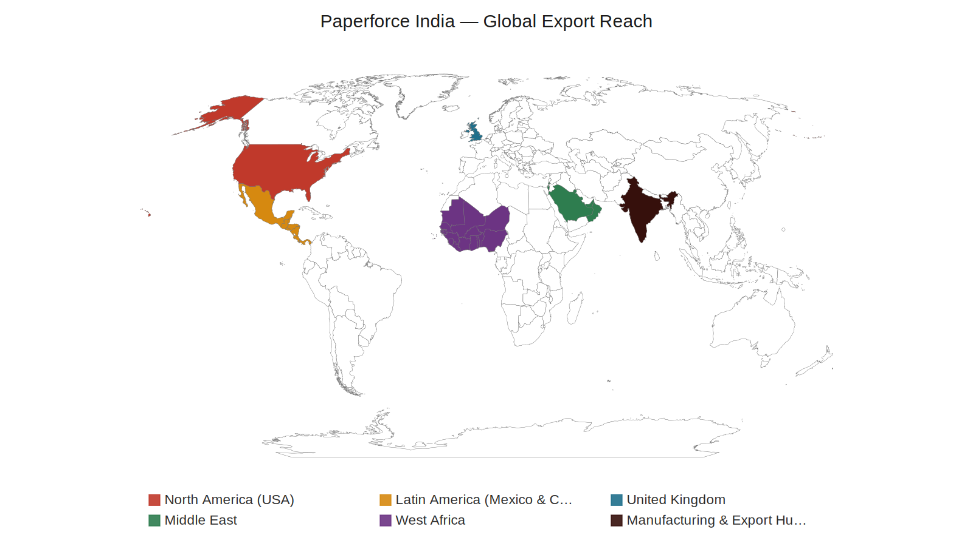
Illustrative map of current Paperforce India export markets, shipped via Nhava Sheva (JNPT).
3. Regional Breakdown
- North America — United States: supplying importers and chain-store buyers with consistent, export-ready volumes.
- Latin America (Mexico & Central America): an expanding market for cost-competitive, quality-inspected notebooks.
- United Kingdom: a long-standing destination for our notebook and stationery exports.
- Middle East — Saudi Arabia, UAE (Dubai), Oman, Israel, Bahrain: serving distributors and stationery brands across the Gulf and Levant.
- West Africa: a core growth market for bulk exercise books and everyday stationery.
4. Export Process & Logistics
1. Order Confirmation → 2. Production → 3. Pre-Shipment AQL Inspection → 4. Export Documentation → 5. Shipment via Nhava Sheva (JNPT) → 6. Delivery to Destination Port.
5. Stats Counters (proposed)
[Pending client figures] e.g. “5 Global Regions Served” · “10+ Years Exporting” · “AQL-Inspected on Every Shipment”.

CTAs on This Page
- Page-end → “Don't See Your Region? Get in Touch” (Contact Us)

Assets & Info Needed
- Any real shipment/customer data by country, to sharpen or replace the illustrative map
- Confirmed stats for the counters section (countries served, years exporting, etc.)
- Icons for the 6-step export process graphic
Content note: The map groups countries by region for a clean visual. If the client can share actual shipment/customer data by country, a more precise, data-backed version can replace this illustrative one.

7. Open Items — Information Needed From Client
The following details weren't in the brief; every page above is structured to receive them, and they should be confirmed before design/build begins.
A. Brand & Positioning
- Final approval of proposed SEO keyword targets per page
- Confirmed founding/incorporation year and any heritage milestones for the About timeline
B. Contact & Social
- Live business email address and phone number
- Business WhatsApp number (confirmed separate from personal WhatsApp)
- Social media profile links/handles (Facebook, Instagram, LinkedIn, Pinterest)
C. Product & Infrastructure
- Paper packaging vertical — product specifics, formats and use cases
- Confirmation on private-label / customisation capability for Products page
- Certifications (ISO, FSC, BIS, etc.), if any, for the About/Infrastructure page
- Production capacity figures, workforce size, and machinery highlights
D. Sales & Fulfilment
- FAQ answers: MOQ, sample policy, lead times, payment terms, shipping Incoterms
- Any real shipment/customer data by country, to sharpen the Reach/Markets map and stats counters
E. Media
- Product photography and facility/factory photography for all pages
- Newsletter tool/provider to connect the Blog signup form

